CONFIDENTIAL: TLP AMBER + STRICT
FMI Assurance Questionnaire

Purpose:
Financial Market Infrastructure (FMIs) and their participants (i.e. clients) have a shared interest in assuring the sector’s resilience. All participants in the financial market can adversely impact the financial stability and/or markets if their Important Business Services are not resilient.
FMIs and Firms comply with the same operational resilience and business continuity regulations. They all make detailed operational resilience self-assessments available to the Bank of England, PRA and FCA. Therefore, the purpose of this questionnaire is to understand the macro vulnerabilities that exist in relation to business continuity and operational resilience between FMIs and their clients.
This questionnaire aims to be the next step in the dialogue between FMIs and clients. It is acknowledged that there are scenarios that challenge all sector participants to remain within impact tolerance and operational resilience is an evolving discipline that continues to mature. The spirit is to be collaborative and non-judgemental.
As an industry agreed questionnaire, FMIs will only provide a response in this template and will not respond to individual surveys and questionnaires.

CMORG-endorsed capabilities (including good practice guidance, response frameworks and contingency tools) have been developed collectively by industry to support the operational resilience of the UK financial sector. The financial authorities support the development of these capabilities and collective efforts to improve sector resilience. However, their use is voluntary, and they do not constitute regulatory rules or supervisory expectations; as such, they may not necessarily represent formal endorsement by the authorities.

Questionnaire’s Aims and Objectives:
- Rapidly initiate a standard sector FMI questionnaire that can be further developed in subsequent years (Agile approach).
- Allow the sector to reach a common understanding of the FMI’s resilience and collectively agree on areas of focus.
- Recognise that FMIs are regulated entities, and applying a standard Third-Party questionnaire is not appropriate.
- Reduce duplication, many existing Operational Resilience questionnaires asked for information already provided in other surveys or reports, now will be referenced but not repeated
- Simplify to aid understanding, responses should be understandable to our IBS stakeholders/senior managers, not just by third party and operational resilience specialists.
- Shift the focus towards understanding the residual risk and vulnerabilities, rather than scoring responses.
- Free FMIs time and resource to focus on more collective industry engagement, such as, symposiums, Q&A sessions, Show & Tells, as well as exercising and testing to drive sector resilience.
- Pave the way for banks to provide reciprocal information to the FMIs to allow them to understand their clients’ resilience and a deeper understanding of their impact on their client.
- Develop the dialog, collaboration and understanding between the FMIs and Banks on resilience topics.
- Allow banks to collectively review and feedback on responses to the questionnaire bringing efficiency and greater impact.
- Provide a consistent message on FMI resilience in our Operational Resilience Self-Assessments.
- Support banks in meeting their regulatory requirements under FCA PS 21/3; FCA SYSC.15 A; PRA SS1/21; PS6/21; and PRA Rule Book.

Example answers:
Sample answers have been included for illustration and are in red italics.

Overview

Please provide links to due diligence material and/or accreditations that you make available to participants, to support answering any further questions on your FMI’s resilience beyond this questionnaire:
Item | Web link if available
e.g. ISO 22301 | www.acme.com/BCP
e.g. SOC 2 audit | www.acme.com/BCP
e.g. SO/IEC 27001 | www.acme.com/BCP

Provide an overview of your FMI’s Important Business Services (IBS) and their associated Impact Tolerances. Include the context/rationale on how the Impact Tolerances were determined. Explain how this avoids harm to financial stability, markets, client, and/or safety & soundness. This allows your clients to assess if their IBSs that are dependent on you are covered by your operational resilience programme.
IBS Name | Brief Description of the IBS | Impact Tolerances | Context/Rationale
e.g. Domestic Settlement of UK Sovereign Debt Securities. | This is the settlement of the UK Gilts Market. Euro and Dollar currencies are not considered part of our IBS. | Within 2 weeks of the last Gilt auction organise but the DMO.
e.g. Domestic Settlement of Equities. | Settlement of equity trades from the LSE. Euro and Dollar currencies are not considered part of our IBS | Service must recover by the end of the settlement day, (including clearing of the backlog), following a disruptive event.

Operational Resilience

Provide a high-level description of your FMI’s operational resilience including Structure & Governance:
Response
In line with the latest regulatory expectations and guidelines, ACME’s Resilience programme encompasses a mature programme aligned to industry best practices to ensure Enhanced Operational Resilience. Operational Resilience minimises the risk and impact of an unplanned disruption on markets and participants and ensures the safety and soundness of ACME’s most important business services. It includes risk mitigation beyond standard BCM scenarios, including cyber-attacks. A team of full-time professionals are responsible for managing and monitoring the Firm’s preparedness for both standard and severe scenarios.

Describe your FMI’s current cyber operational resilience capability including any future plan work. Please contextualise in terms of the proposed CMORG Cyber Protection and Restoration Principles in development (see Annex A).
2.2.1 Governance and Strategy
We have a cyber policy endorse by our board and this manage by the group cyber committee. The board have a quarterly update on cyber.
2.2.2 Prevention and detection
We use enterprise grade security software across our IT estate. We have comprehensive cyber policy applied by our CISO function, with 24x7 monitoring.
2.2.3 Containment and Security Assurance
Cyber containment at our company is a proactive and structured process designed to rapidly limit the scope and impact of a security incident. Our approach is built on the core incident response lifecycle phases defined by the National Institute of Standards and Technology (NIST), including preparation, detection, analysis, and post-incident activity. We emphasize clear communication, both internally and with external partners, to ensure a coordinated and effective response. Key actions include isolating compromised systems, applying temporary security measures, and continually monitoring and reassessing the situation.
Upon identifying a potential incident, our trained Incident Response Team (IRT) immediately initiates the containment strategy. The strategy is determined based on a predefined severity matrix and the nature of the threat, guiding the team to select the most appropriate containment approach, such as full, partial, or selective isolation. Actions can range from disabling network connectivity for infected endpoints and disabling compromised user accounts to applying temporary firewall rules that block malicious traffic. We also use automated tools for swift, decisive action, and continuously monitor for new indicators of compromise to adjust our response dynamically. Crucially, all actions are meticulously documented to support forensic analysis and to inform our post-incident review, helping us learn from each event and improve our security posture for the future.

We engage independent expertise where appropriate and openly provide evidence and assurance in support of technical considerations in response to a cyber incident
2.2.4 Desktops, Laptops and Collaboration Services Restoration
In addition to the contingency workarounds, technology resilience capabilities may be implemented to support the longer-term recovery from a cyber-attack; all applications in scope for technical resilience (cyber vaulting) are required to have a run book written and a recovery test conducted to demonstrate the recovery of the minimal viable application service required by the business to remain with ITol. It is acknowledged that there are limitations to the extent to which critical application cyber vault recovery tests are performed, which are executed as individual tests rather than as multiple, interdependent (upstream and downstream) application recoveries from vault to clean room.
2.2.5 Core Infrastructure Restoration
For Core Infrastructure Restoration technologies which underpin the provision of all IBS, have an appropriate resilience approach for these applications and infrastructure components, and oversee the implementation of on premise or cloud-based cyber resilience (vaulting) solutions.
2.2.6 Business Applications and Data
Our cyber vault provides a consistent solution to securing critical materials (away from the primary source) in a cloud based immutable (tamper proof) store. This solution is intended for emergency pre-authorized use immediately following a cyber-event when the primary source is unavailable. This is in support of the manual alternative processes that are applicable to the impact tolerance limits to prevent intolerable harm leveraging files and supporting information.
2.2.7 Third Party Reconnection
To restore secure third-party connections after a cyber incident, our company follows a rigorous, multi-phased approach that prioritizes investigation, validation, and enhanced security controls. First, we immediately sever all network access and API connections related to the compromised third party, using secure communication channels to open a dialogue with their incident response team. A collaborative, deep-dive investigation then assesses the incident's root cause and confirms that all vulnerabilities have been fully remediated and validated by the vendor. We do not restore any connections until this validation is complete, and we have received satisfactory reports, including evidence of their security posture improvements, such as penetration test results and strengthened internal security policies. Finally, to re-establish the connection, we implement a new, strengthened security framework. This includes enforcing Multi-Factor Authentication (MFA), adopting a least-privilege access model, and enhancing our continuous monitoring of the vendor's activity for any sign of anomalous behaviour. This disciplined process ensures we do not simply reconnect, but rather, we rebuild the partnership on a more resilient and secure foundation.
2.2.8 Contingencies
We design and implement contingency measures to be undertaken by the business which circumvent critical resources and allow the IBS to manage the immediate response to a severe but plausible disruption. As part of this, an IBS response playbook was introduced to assist IBS leads and relevant SMEs by setting out a ‘command and control’ model for management of critical day zero activities such as client communication, prioritisation of payment activities and other risk mitigation contingencies whilst closely monitoring a potential breach to IT

Describe your FMI’s current third party resilience capability work to assure your third parties and any future planned assurance activities:
Response
We perform due diligence on all third parties before onboarding that covers their resilience and have contractual terms related to resilience in the contracts. Where possible we have alternate providers in place and/or a strategy to temporarily insource the critical function or workaround.

Provide dates of any testing of the above IBSs and include the test objectives that were achieved:
Frequency | Description: Type of Testing / Scenarios | Governance / Assurance on the Outcomes Achieved
May-24 | Cyber | Successful but some lessons learnt around sequencing of recovery.
Feb-25 | Loss of third party data centre | Successful but will be making some changes to our command and control.

Does your FMI offer any industry testing which clients can participate in? If so, please provide the date and contact or the details of how they can participate.
Response
Data centre fail over test for participants, Saturday, 16 August, please email testing@acme.com

Highlight any scenarios where you would be more challenged to remain within your impact tolerances? This is for awareness of challenging scenarios and is not an assessment of would you stay within ITOL. This is to understand the macro/sector vulnerabilities that the sector faces. Some of these will not be immediately obvious to your participants e.g. your reliance on other FMIs, third parties or market participants. Some of these will be extreme scenarios e.g. telecoms outage or targeted cyber-attack.
Response
- A targeted cyber-attack by a nation state
- Loss of one of these providers:
  - Swift
  - British Telecom
  - Chaps/RTGS

Are there any points around disconnection you would advise your FMI’s participants to consider or should be made aware of? Are there any procedures published you would direct your participants to?
Response
We would never look to actively disconnect ourselves from the market. Generally, we will allow transactions to queue until we could process. If we can continue to process reduced volumes of transaction or process with delays, we would. We would potentially continue to process transactions if we were able to in a cyber event. If participants decide to disconnect of their own accord and we are still processing, they will be responsible for any unmet obligations. Please refer to our non-standard closure and long-term outage plans.

Are there any points around reconnection you would advise your FMI’s participants to consider or should be made aware of? Are there any procedures published you would direct participants to? Please refer to any communications plans or playbooks you may have.
Response
We would look to leverage the CMORG System Integrity Reconnection Framework if applicable. Generally, following a disruption, we would look to extend the settlement window and then restart as soon as possible. However, if we were to suffer a long-term outage we would restart processing on the following working day, this would be to allow participants to review their outstanding transactions and amend as needed. We would communicate and consult with participants but once we have confirmed the restart time all participants must be ready. First, we will process all queued transactions in the order they were received.

Detail how your FMI fulfils your collective crisis response role with participants as part of the Sector Response Framework? Please reference:
- Communication arrangements with participants during a crisis.
- Response committees you invoke as part of this response.
- Any playbooks which participants should be aware of as part of their own response plans.
- Any joint exercising/testing of these playbooks you have done with participants.
Response
- Depending on the nature of the crisis, communications with participants will either be direct, via service alerts or via one of the service specific Operations Committees
- Fully embedded Sector Response Framework within all our crisis management documentation including active membership of CMBCG, ICG, BOCC etc

Business Continuity

Describe your FMI’s capability to mitigate an unavailability of a critical offices/facility (not including Data Centres) with associated RTOs:
Response
We have a resilient home working solution for all staff that is not reliant on their primary office. In addition, we maintain a disaster recovery site for critical staff.

Describe your FMI’s capability to mitigate an unavailability of critical staff with associated RTOs:
Response
Our operations are split across London and Birmingham, if staff are unavailable in one location the staff in the other location can pick up.

Describe your FMI’s capability to mitigate an unavailability of critical IT or a Critical Data Centre with associated RTOs:
Response
We have two geographically separated data centres. Critical Systems are either load balanced between the two data centres or have a backup instance in the alternate data centre. We perform an annual simulation of a complete loss of one data centre.

Confirm if you have any critical subcontractors including cloud providers, to enable assessment of supply chain risk
Response
We have a mature and well-developed governance framework for Third Party Risk Management. Our cloud services are split between Azure and AWS.

Are there any other comments or information you would like to share that may be relevant to your operational resilience or business continuity that is not already captured in the questionnaire? (Optional)
Response
None

Thank you for taking the time to complete this questionnaire.

END.

Annex A - CMORG Cyber Protection and Restoration Principles (in development)
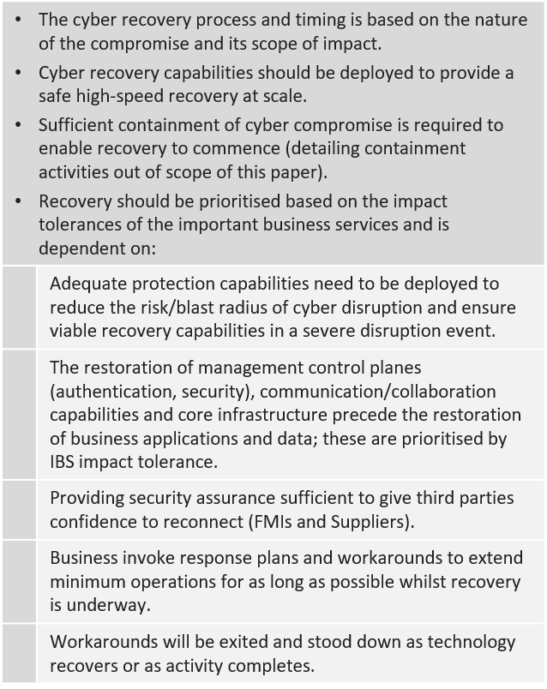
Proposed Industry Principles: Minimising the impact of a severe cyber disruption requires deployment of appropriate protection capabilities, ability to restore required Important Business Service technology & data at scale and employing business response/workarounds to mitigate impact during recovery.
7
6
5
4
3
2
1
¹ For example, E-mail and chat services for colleagues using Bring Your Own Device; ² Recovery of operational technology capability e.g. active directory, authentication, security, access control, telemetry; ³ Contingent processes which solve for common resilience vulnerabilities e.g. payments, funding the firm & communications; ⁴ Beyond minimum data reconciliation\repair needed to re-establish IBS capabilities required within the recovery scope.

